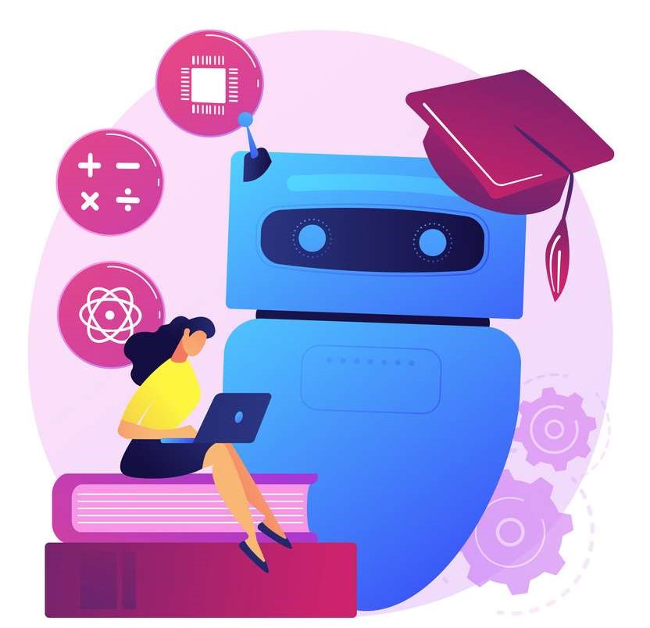

SMART AI CHATBOT

PROJECT 1

MALVIKA SINGH |20BCE0857

ABOUT SMART AI CHATBOT

A chatbot is a type of Artificial intelligence software which can make a conversation with a user in the preferred language through messaging applications, mobile apps or on any website.

Being a part of the most promising for the future of the AI (Artificial Intelligence) as an interaction between the machine and the humans.

MY ROLE:

The project was individually completed by me.

WHAT I LEARNED AND HOW I EXCECUTED:

The Bot that I have made for this project is very basic. The very first thing which I learned to make was the file intents.json which is used to construct the files classes.pkl and words.pkl. An important function that I learned to include in my chatbot is being able to pull the lead data and information from people who are interacting with our bots either by using native integrations built into the chatbot software.

To implement the chatbot we will be using Keras which is a Deep Learning library. NLTK which is a Natural Language Processing Toolkit and some helpful libraries.

Some of the modules due to versions were downloaded in a virtual environment. The steps to activate a virtual environment is in the readme file.

The line written is the chatbot will break down the user sentence into two things: Intent and an Entity. The intent for this sentence could be get news as it refers to an action the user wants to perform. The entity tells specific details about the intent, so here ‘today’ will be the entity. So, this way a machine learning model is used to recognize the intents and entities of the chat.

For processing the data: the data goes under a lot of processing for machine to easily understand.

Tokenizing: When the sentence is broken the tags are identified and accordingly the bot responses from the java file created intents.

Lemmatization is a technique through which we convert a form of the words to the main or canonical word. Example: write, writing, writes, wrote etc. will get converted to write. This way we reduce the number of total words in our vocabulary and reduce a chance of duplicity.

Create training and testing data: To train the model we convert the input into numbers. Then we lemmatize each word of the pattern and create a list of 0’s of the same length as the total number of words. We will create the output by setting 1 to the class input pattern belongs to.

Training the model: I used neural network consisting of 3 Dense layers. Using SGD optimizer and fir the data to start the training. After the training with 200 epochs we save the training model using Keras model.save(“chatboit.h5”) function.

Interacting with the chatbot: After training and forming a model now I created a graphical user interface (GUI). The file chatbot.py. I used Tkinter module and then read the input and then after some reprocessing the message is added to the trained model.

The model will read the input and recognize the tag and randomly choose the output from the intent file that we created.

And that was the last part and now we can adjust the color and structure of the chatbot to make it more appealing and enjoy talking to a bot.

Libraries or modules required:

All the modules and libraries needed are in the necessities file.

Data:

The components given below the files created by me and the files that were constructed using the codes

Here’s a quick breakdown of the components:

1. Trainchatbot.py - In this file, I build and trained the deep learning model that can classify and identify what the user is asking to the bot.
2. Chatbot.py - This file is where I hav build a graphical user interface to chat with our trained chatbot.
3. Intents.json - The intents file has all the data that I used to train the model. It contains a collection of tags with their corresponding patterns and responses.
4. Chatbot_model.h5 - This is a hierarchical data format file in which I have stored the weights and the architecture of my trained model.
5. Classes.pkl - The pickle file can be used to store all the tag names to classify when I predicting the message.
6. Words.pkl - The words.pkl pickle file contains all the unique words that are the vocabulary of my model.

References: https://www.techwithtim.net/tutorials/ai-chatbot/part-1/

https://medium.com/predict/creating-a-chatbot-from-scratch-using-kerasand-tensorflow-59e8fc76be79

https://towardsdatascience.com/deep-learning-for-nlp-creating-a-chatbotwith-keras-da5ca051e051

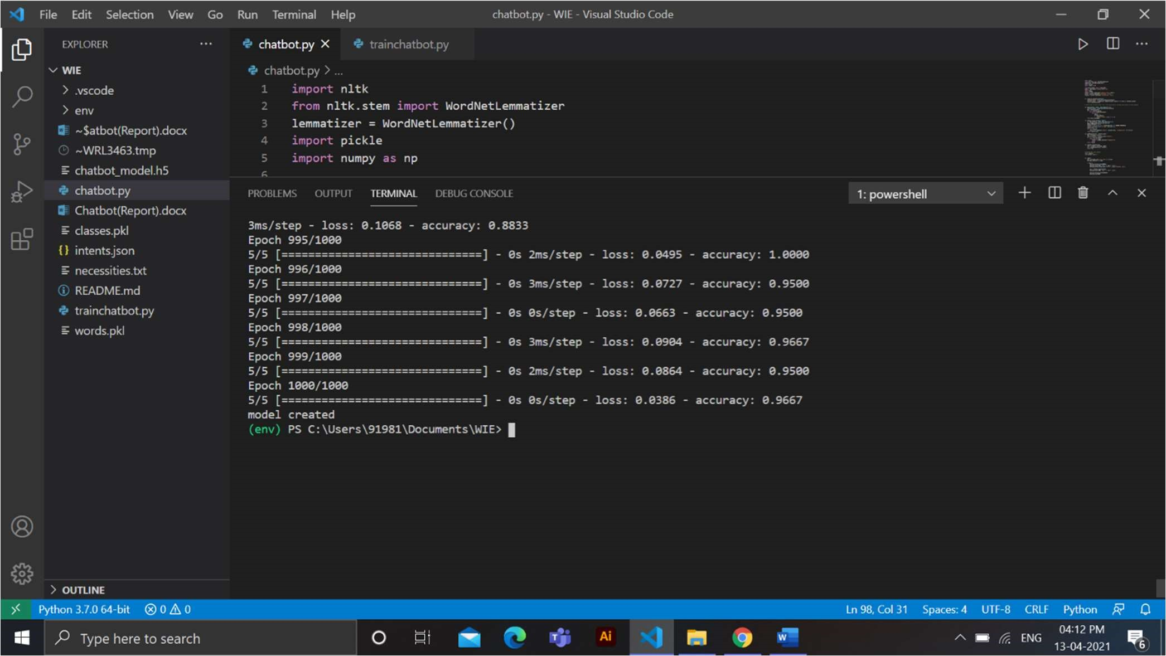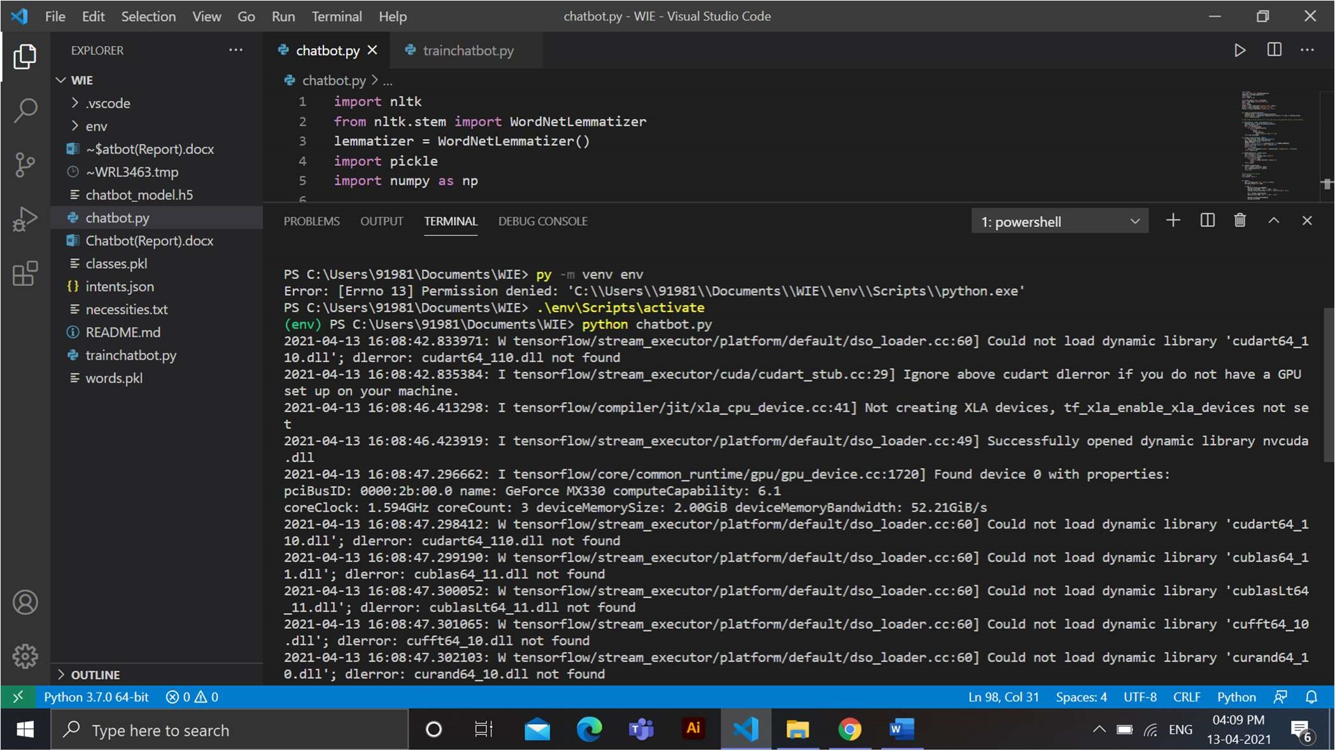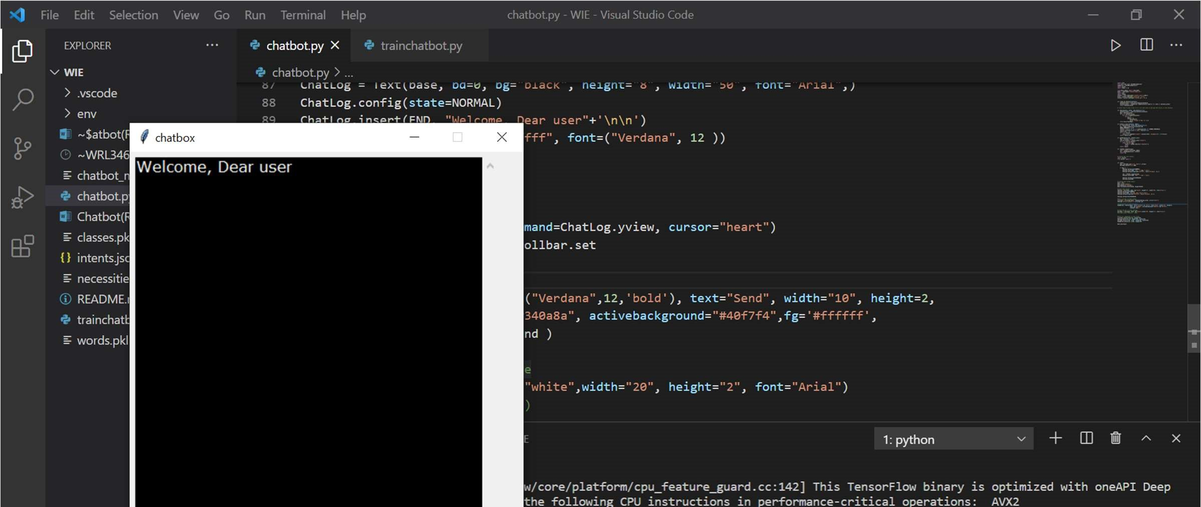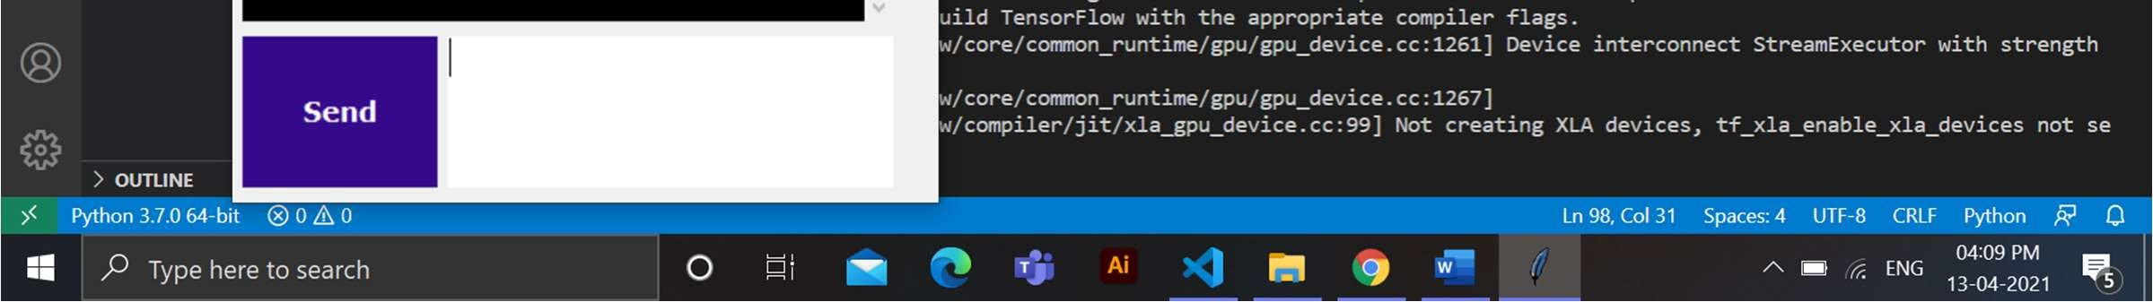

Github link:

<https://github.com/malvikasingh14/Project_Chatbot>